SURVEY USING SAMPLE
Pearson Edexcel - Thursday 9 June 2016 - Paper 2 (Calculator) Higher Tier
1.
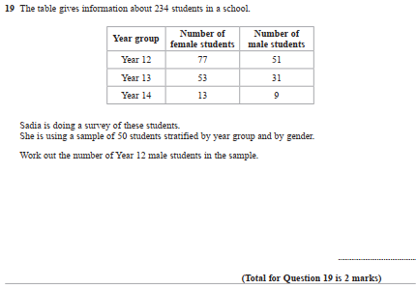

Pearson Edexcel - Friday 6 November 2015 - Paper 2 (Calculator) Higher Tier
2.
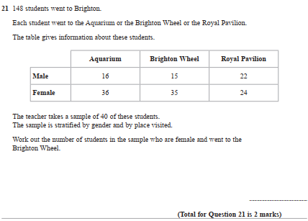
Pearson Edexcel - Friday 13 June 2014 - Paper 2 (Calculator) Higher Tier
3.
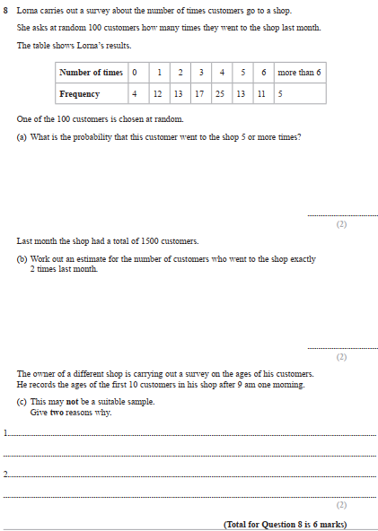

Pearson Edexcel - Friday 13 June 2014 - Paper 2 (Calculator) Higher Tier
4.
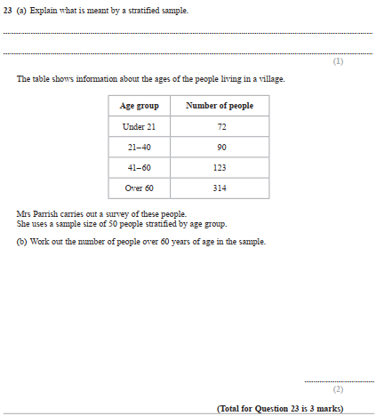

Pearson Edexcel - Monday 11 June 2012 - Paper 1 (Non-Calculator) Higher Tier
5.
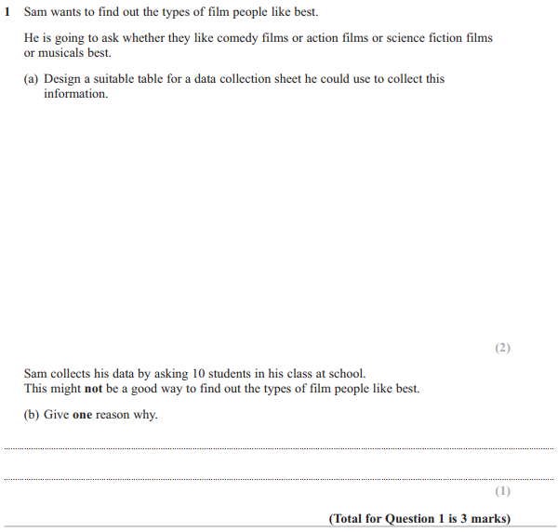

Pearson Edexcel - Friday 11 June 2010 - Paper 4 (Calculator) Higher Tier
6.
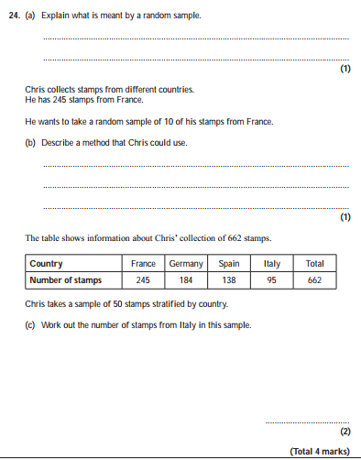

Pearson Edexcel - Tuesday 10 November 2009 - Paper 4 (Calculator) Higher Tier
7.
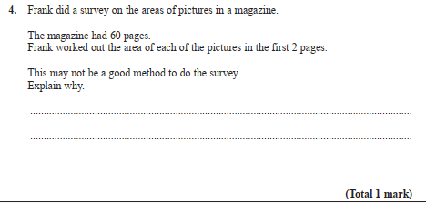
OCR GSCE – Tuesday 2 November 2017 – Paper 4 (Calculator) Higher Tier
8.
